# Exporters

### Exporters Abound

Data is pulled from various data sources using lightweight agents called an **Exporters** that are installed on or attached to the data sources themselves. Once it knows about an exporter, Prometheus "scrapes" data from those exporters every few seconds. No matter how many exporters you have providing data, Prometheus can scrape them all and happily collect your monitoring data in near real-time.

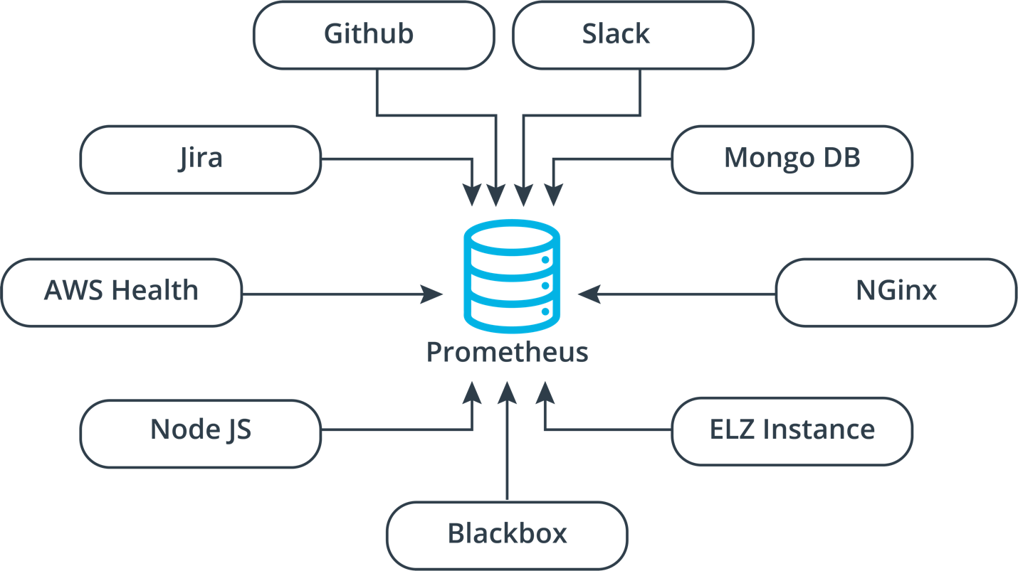

**Prometheus Works with Lots of Different Data Sources!**

### Node Exporters

### Available Exporters

| **Exporters** | **Purpose** |
| --- | --- |
| [Node exporter](https://github.com/prometheus/node_exporter) | Provides basic operating system metrics like CPU, Disk and Memory Usage. |
| [Nginx VTS Exporter](https://github.com/hnlq715/nginx-vts-exporter) | Provides metrics on connections, server zones, and upstream requests. |
| [Blackbox exporter](https://github.com/prometheus/blackbox_exporter) | The Blackbox exporter allows black-box probing of endpoints over HTTP, HTTPS, DNS, TCP, and ICMP |
| [Github Exporter](https://github.com/infinityworksltd/github-exporter) | Provides metrics on repository commits, pull requests, and issues. |
| [MongoDB Exporter](https://github.com/percona/mongodb_exporter) | The MongoDB exporter periodically scrapes MongoDB server stats. |
| [Jira Exporter](https://github.com/AndreyVMarkelov/jira-prometheus-exporter) | Provides metrics on Jira issues and projects. |
| [Swagger Stats](https://github.com/slanatech/swagger-stats) | API performance stats available to Prometheus |
| [AWS Health Exporter](https://github.com/Jimdo/aws-health-exporter) | Provides health metrics on all AWS services and regions. |

... and [many more](https://github.com/prometheus/docs/blob/master/content/docs/instrumenting/exporters.md).

Even with all these existing exporters, you might need something that doesn't exist yet. The documentation is very helpful and mature, but there's a steep learning curve. One way you can flatten that curve a bit is to use an existing exporter and modifying it.

### Key Terms:

* **Exporter**
* **Pull System**